Newlands Primary School Digital Technology Parent Information
Aims
To enhance and embed the use of Digital Learning and Teaching (DLT) to promote and encourage the benefits DLT offers to all learners
To provide equal access to DLT for all learners
To support high quality learning and teaching using DLT

Expectations
DLT will be used daily throughout the curriculum when appropriate to enhance learning outcomes.
All learners will be taught online safety as part of the curriculum at the appropriate level using websites such as ThinkUKnow. CEOP Education (thinkuknow.co.uk)
Mr Kaljee is the DLT champion in the school and takes responsibility for acquiring the right skills to support DLT in school and supporting the all staff to develop DLT skills.
The DLT champion also deals with IT issues in the school and supports both staff and learners when possible. The DLT champion reaches out to professional helpdesks if IT problems can not be solved in school.
Staff are regularly asked if they need additional training to support their DLT skills, it is part of the PRD process too. Training will be provided by the DLT champion and SBC Inspire.
Senior Leadership Team (SLT) in school evaluates the added value of new technologies that become available either nationally or locally and make decisions. Through a consultation process with staff, pupils and parents will decide if implementation will be appropriate to meet the needs of Newlands pupils.

Teacher role
Teachers will assess for all lessons if DLT can enhance children’s learning experience.
DLT will be experienced in each class on a daily basis.
IT skills will be taught at the appropriate levels from P1 to P7
Internet safety will be taught using national accredited resources such as ThinkUKnow website.

Pupil and Parent guidance
Pupils are responsible for looking after all IT equipment made available to them by the authority both at school and at home as stipulated in the SBC user agreement.
Individual Ipads (P4-P7) are the responsibility of the pupils and parents.
When Ipads go home they must be returned the next school day charged and ready to use.

Below is a sample of current programmes frequently being used to support DLT
All these apps are used across all curriculum areas as appropriate on Ipad or laptop.

P1/2
Doorway online: Doorway Online keyboard skills, literacy numeracy at Early level
Topmarks Topmarks: teaching resources, interactive resources, worksheets, homework, exam and revision help literacy and numeracy
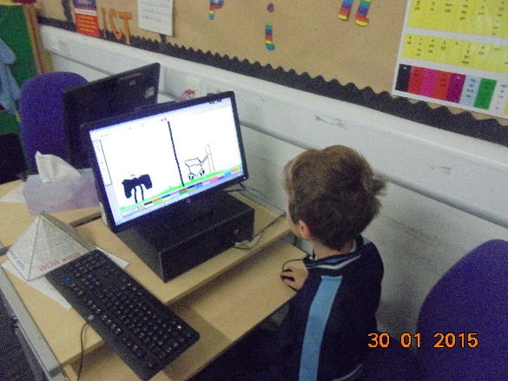
Number Crew https://youtu.be/tVFU0aYQXk8 number bonds, shape facts

On Ipad
Sketches – school for drawing P2
Notes for drawing P1
Garage Band for music
Safari – for basic controlled topic based research P2
Word – using voice control button to check spelling of words
Showbie (still under development)
Camera – to create evidence (sometimes by using the school digital camera)

P3/4/5
Word
Sumdog – Maths tasks in class and homework
Safari - for research
Powerpoint
BookCreator – to create interactive texts for literacy, HWB and topic work.
Sketches school
Camera – pictures and movies for evidence of work
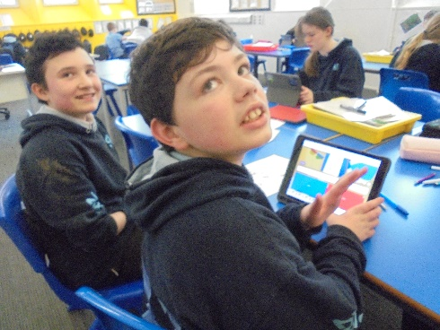
Kahoot - create quizzes to assess knowledge
Notes
Showbie - Topic tasks

P6/7
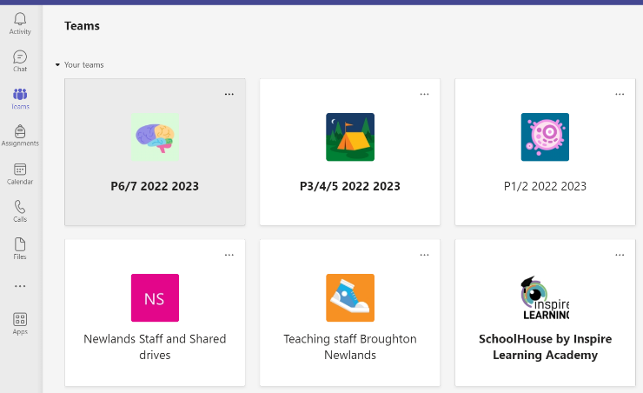
All these apps are used across all curriculum areas as appropriate on Ipad or laptop.
Word
Sumdog – Maths tasks in class and homework
Folders – organising work
Safari - for research
Powerpoint
Outlook – for emails
Teams - for homework
BookCreator – to create interactive texts for literacy, HWB and topic work.
Clips
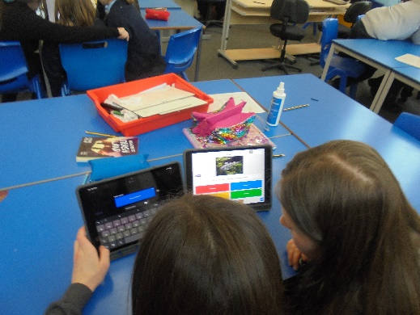
Sketches school
Imovie
Camera – pictures and movies for evidence of work
Kahoot - create quizzes to assess knowledge
Notes
Translate for modern languages
Calendar
Micro-bit - coding
Showbie - Topic tasks
