Best Start Grant | School Age Payment
Social Media Posts

All the posts below fit Twitter’s character limit.
We have included full size images to protect the image quality. To post an image, please right click on the image and ‘save as’ in your preferred location then use to attach to your post.

Post 1 – For Nurseries

Is your little one ready to leave us and take the next big step into P1?
If they were born 1 Mar 2015 - 29 Feb 2016 and you get certain benefits or tax credits, you could get £250 to help with the costs of starting school.
Find out more and apply at mygov.scot/beststart
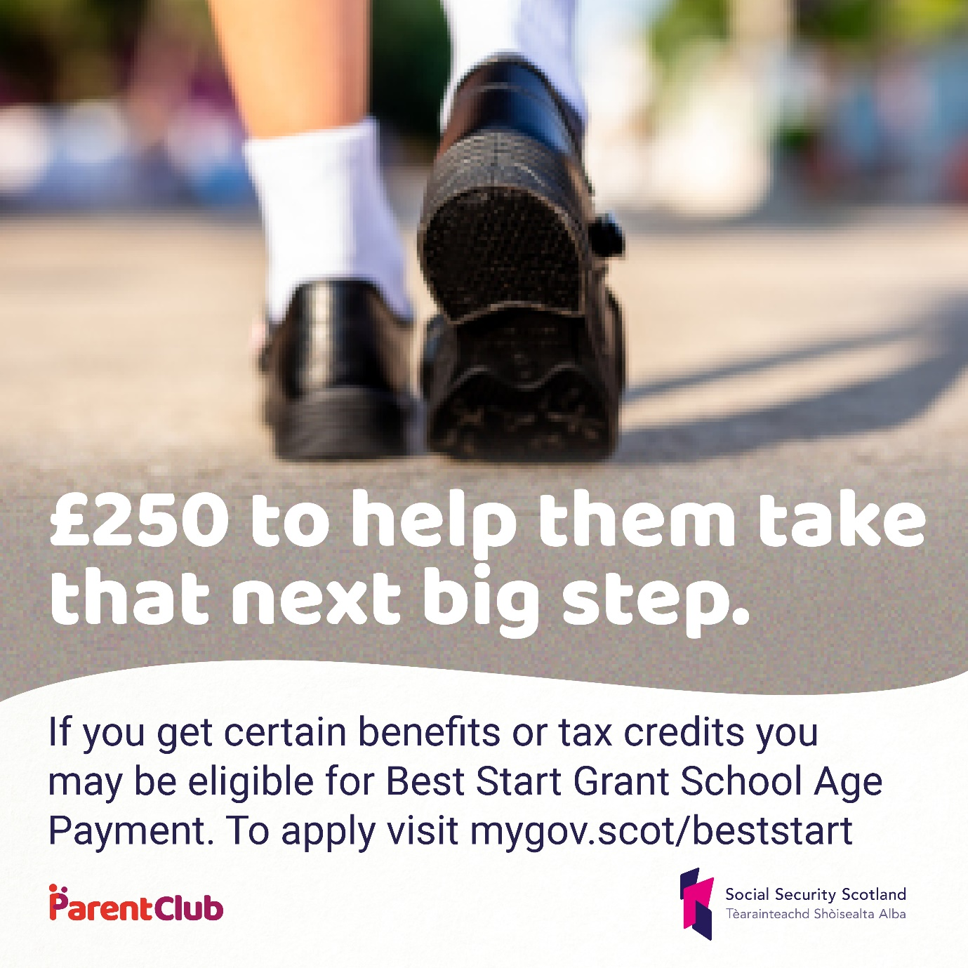

Alt Text: Feet wearing school shoes, walking in a playground. Text reads £250 to help them take that next big step. If you get certain benefits or tax credits you may be eligible for Best Start Grant School Age Payment. To apply visit mygov.scot/beststart

Post 3 – For Schools

The team at @HANDLE are looking forward to meeting all our new P1 pupils.
If your child was born between 1 March 2015 - 29 Feb 2016, and you get certain benefits or tax credits, you could get £250 to help with the costs of starting school Find out more and apply at mygov.scot/beststart

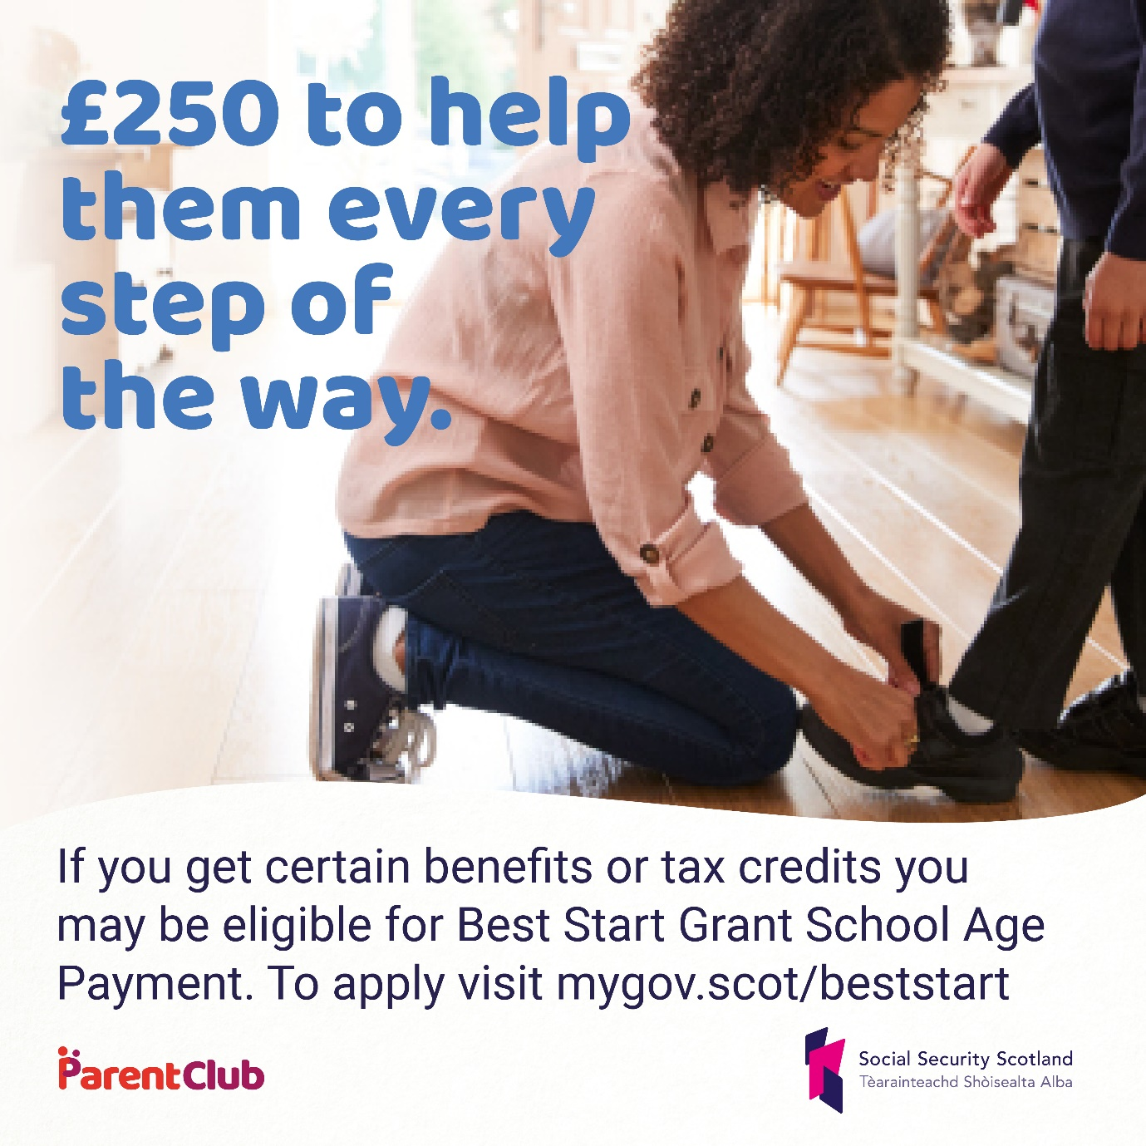

Alt Text: If you get certain benefits or tax credits you may be eligible for Best Start Grant School Age payment. To apply visit mygov.scot/beststart

Post 3 – Families deferring

Are you deferring your child’s school place this year? Was your child born between 1 March 2015 - 29 Feb 2016?

You should still apply for School Age Payment from @SocSecScot between 1 June 2020 - 28 February 2021.

Apply now at mygov.scot/beststart

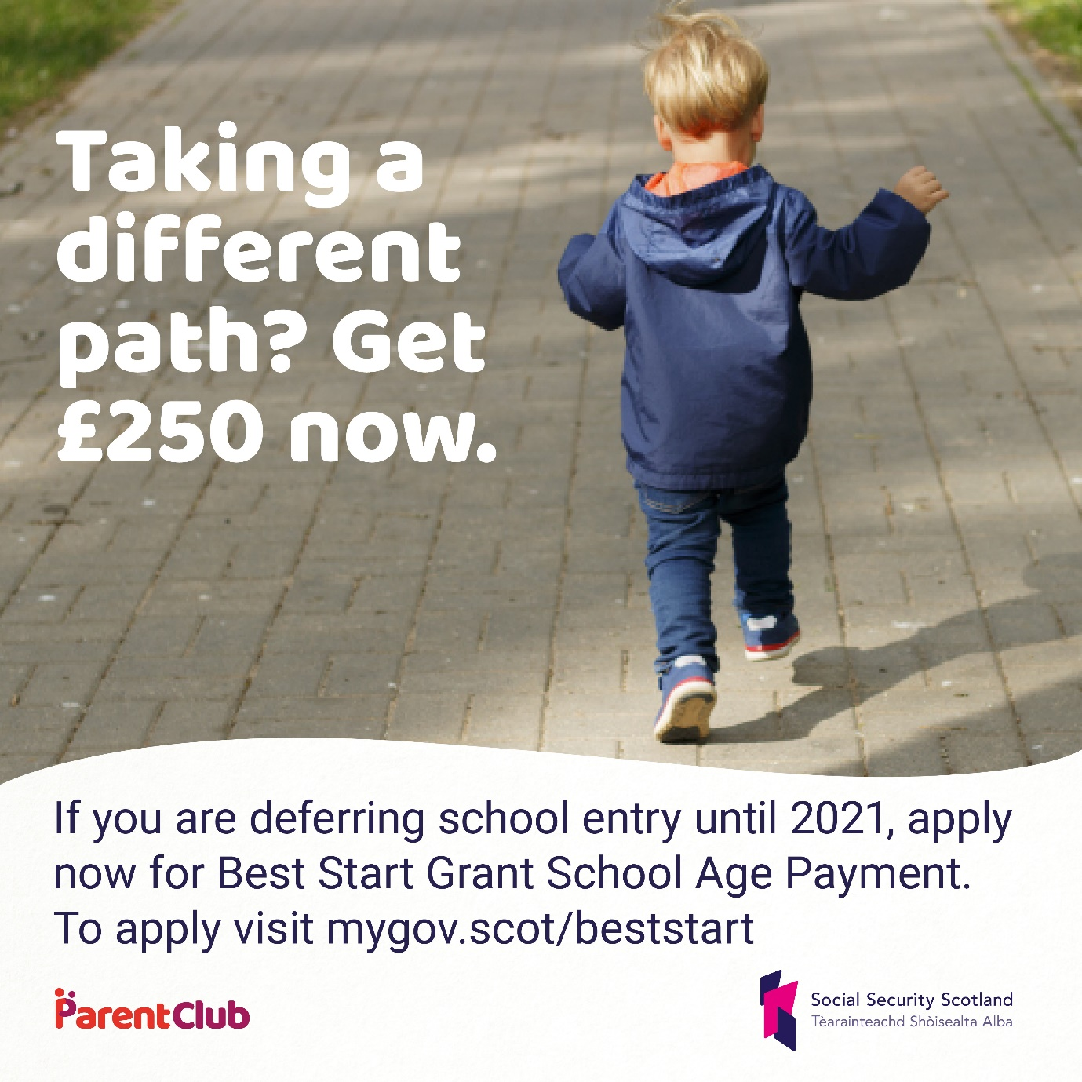

Alt Text: A child walking away from the camera. Text reads: If you are deferring school entry until 2021, apply now for Best Start Grant School Age Payment. To apply visit mygov.scot/beststart

Post 3 – General Message

Do you have a child born between 1 March 2015 - 29 Feb 2016?
The School Age Payment is £250 from @SocSecScot to help families who get certain benefits or tax credits to help with the costs when a child would normally start Primary 1.
Fnd out more and apply at mygov.scot/beststart

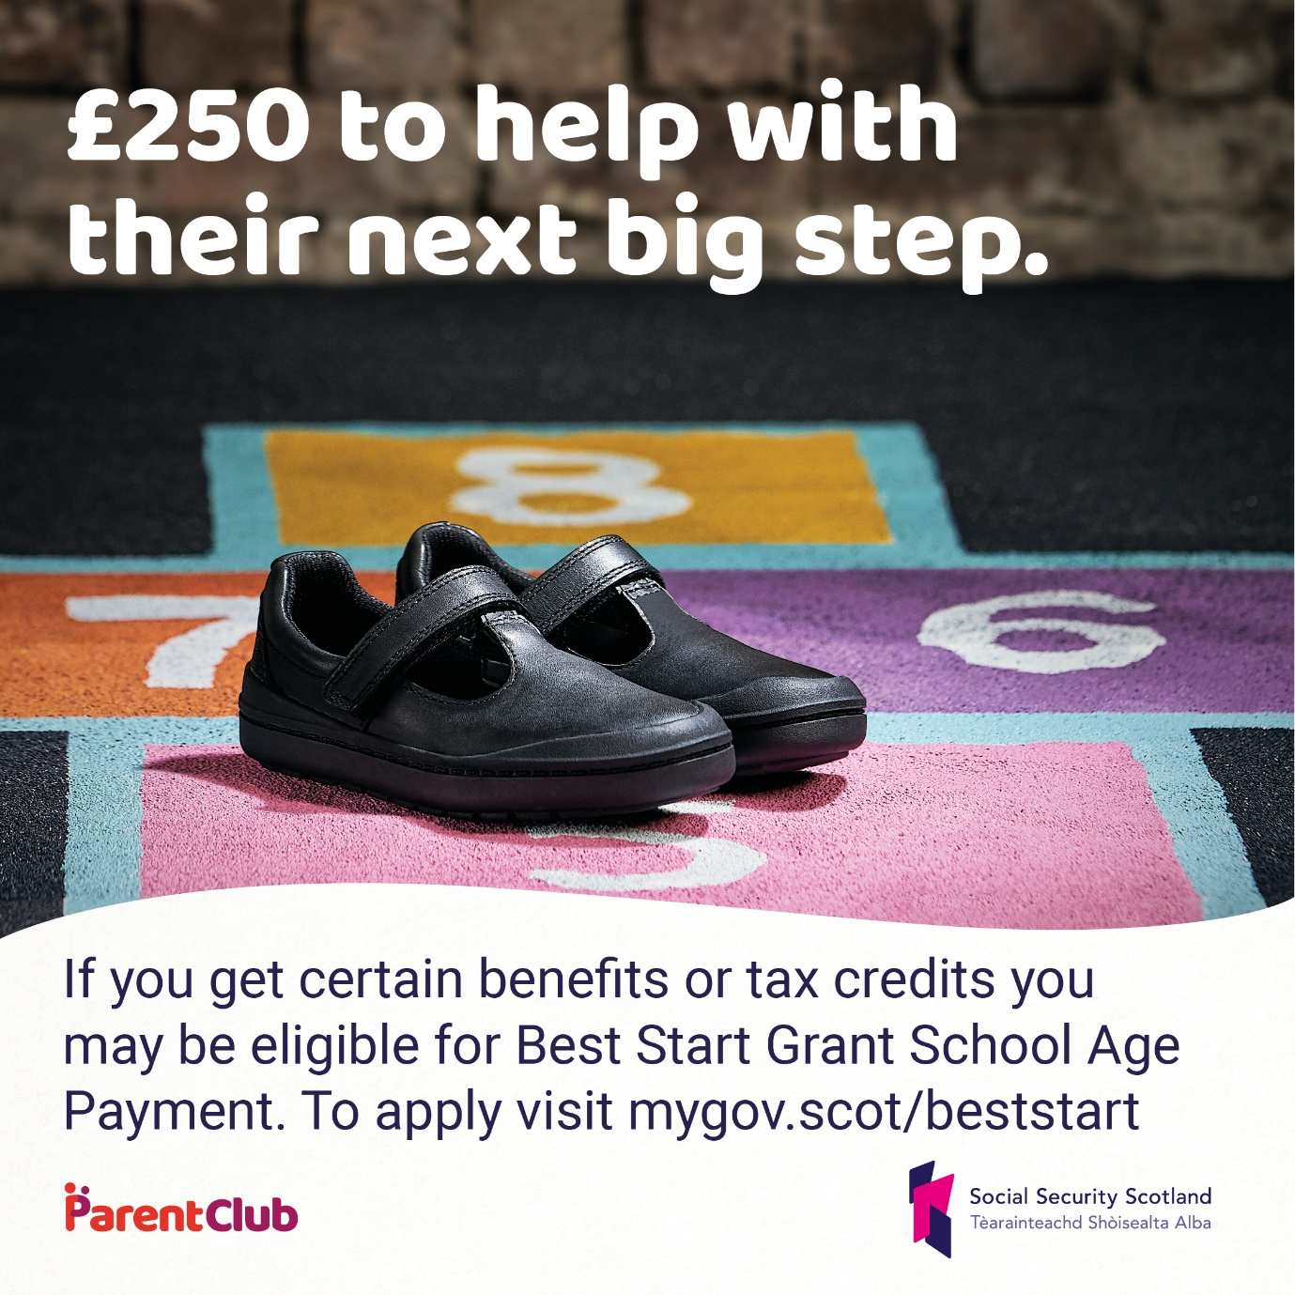

Alt Text: Black shoes are on a painted hopscotch board. Text reads £250 to help with their next big step. If you get certain benefits or tax credits you may be eligible for Best Start Grant School Age Payment. To apply visit mygov.scot/beststart

